S-100 Maintenance - Change Proposal Form

Organisation | Jeppesen | Date | 2016-02-01
Contact | Raphael Malyankar | Email | Raphael.Malyankar@jeppesen.com

Change Proposal Type Select only one option
1.Clarification | 2.Correction | 3.Extension
X

Location Identify all change proposal locations

S-100 Version No. | Part No. | Section No. | Proposal Summary
2.0.0 | 5 | 4.2.2.2 | Add material in 4.2.2.2 explaining super-type / sub-type relationships.

Change Proposal
Please provide a detailed change proposal.
Add a description of the nature and implications of super-type/sub-type relationships and a diagram. Draft text follows with new or changed text in red.

5-4.2.2.2 Inheritance
In data modelling, inheritance is a way to form new types using types that have already been defined. The new types, known as derived types (or sub-types), take over (or inherit) properties of the pre-existing types, which are referred to as base types (or super types). The derived types may define new additional properties, but also change existing properties, the latter is called overriding. This is used to assign unique property values to sub-types such as name and definition but overriding of characteristics such as bindings to attributes should be avoided by only including common characteristics in the super type. In the scope of a feature catalogue both feature and information types can be derived from other feature or information types. But a feature type cannot be derived from an information type or vice versa. Attributes and associations defined for the super type will also belong to the sub type. The definition of the sub type is usually redefined. In the context of this standard inheritance will be always simple, i.e. each type cannot be derived from more than one super type.

EXAMPLE 1 Cardinal and lateral buoys may be derived from an (abstract) type buoy. The super type already defines attributes like colour, shape, name, and associations to lights or top marks. The derived types add special information only valid for the specialized type like category of cardinal mark or category of lateral mark respectively.

Inheritance builds hierarchical structures which may become difficult to manage if they are too complex or not sufficiently mature. It is always generally good design practice to keep the depth of an inheritance tree as shallow as possible. On the other hand, sometimes inheritance trees simplify models by grouping types which are derived from the same basic concept and which have the same characteristics, so inheritance even at multiple levels should be used where appropriate.

Inheritance relationships between types in a feature catalogue generally correspond to inheritance relationships in the application schema. Determinations of when to use inheritance and to what degree and level are information modeling questions and should be addressed by application schema designers and project teams taking into consideration factors such as application schema and feature catalogue complexity, maintenance, application requirements, etc.

EXAMPLE 2 In the information model for the ENC product specification, all geographic feature types have information bindings to the information type SupplementaryInformation and feature bindings to the cartographic feature TextAssociation. Defining a common super-type for all geographic features would allow these two bindings to be made to the super-type instead of repeating them in every geographic feature type.

EXAMPLE 3: In an application schema for an “Aids to Navigation” product specification, classes defining different types of beacons have many of the same attributes. Also, classes defining different types of buoys share the same characteristics. Super-types GenericBuoy and GenericBeacon are therefore defined. Further, buoys and beacons can all act as structure objects, and there are also other features which can also play the role of structure objects, so another super-type is introduced for generic structure features. AidsToNavigation, StructureObject, GenericBuoy, and GenericBeacon are all abstract classes. The Structure/Equipment association is made between the classes Structure and Equipment and applies to all sub-types of these classes, e.g. any CardinalBuoy can fill the parent role in a Structure/Equipment association with any sub-type of Equipment.

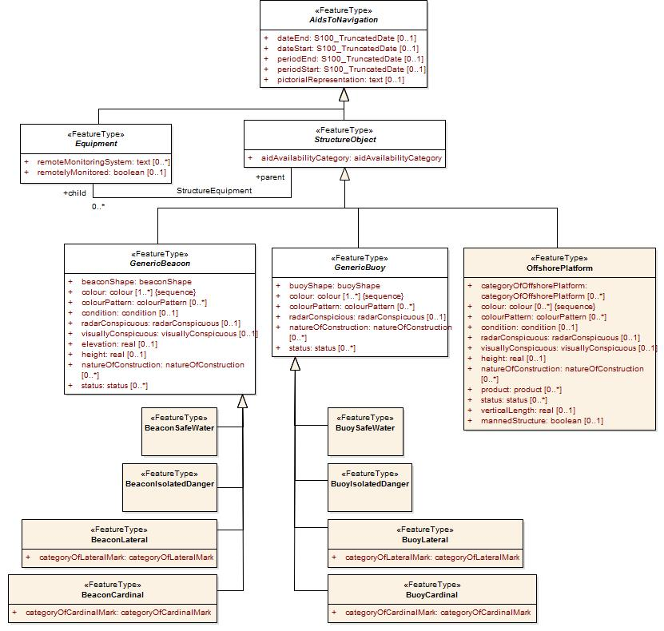
Figure 5-1. Inheritance Example

5-4.2.2.2.1 Considerations for product specifications (Informative)
In general the need for inheritance increases with increasing numbers of concepts which can be grouped under a higher-level concept, or as more characteristics are shared between similar types, or even if several different types share some characteristics.

The advantage of excluding inheritance from feature catalogues is mainly structural simplification (and consequently simpler processing) since abstract types and inheritance hierarchies need not be implemented; also in S-100-based product specifications, inherited enumerated attributes can have different lists of allowed values for different sub-types. The disadvantages include (probable) increases in the volume of the feature catalogue especially if many features or information types have common attributes or associations, and increased complexity for maintenance (an update to an attribute nominally bound to a super-type would have to be made to each sub-type at all levels, and this would have to be checked before the feature catalogue is released). Also, inheritance is a common paradigm in object-oriented programming and may not be a significant issue for implementations.

Change Proposal Justification
Please provide a suitable explanation for the change and where applicable supporting documentation.
The addition clarifies the use of super-type/sub-type relationships in a feature.

